OLD FASHION PEAR PIE

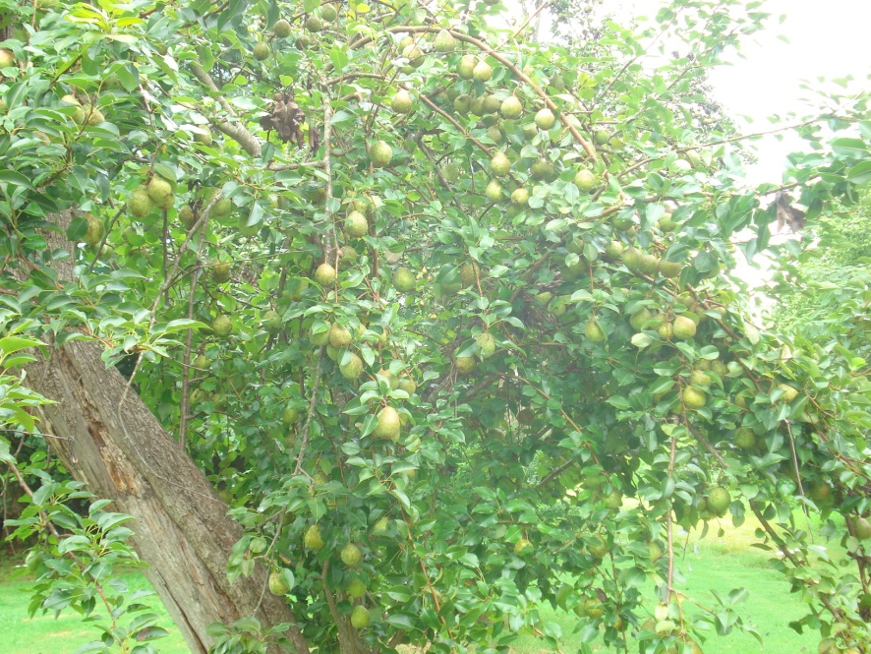

Old Fashion Pear Pie is a recipe from my Mother-in-law Mrs. Bernese Cagle.
She received the pie recipe from Estelle Cagle, which was her Mother-in-law (Albert’s Mother). He then gave me a jar of Bernese’s canned pears to cook in the original pie pan of Estelle Cagle; which this pie pan was handed down to Bernese and now is being passed down to me the third generation. This pie pan has made a many different pies.

The tree was originally planted before 1900; which makes the tree over 100 years old and is at the Cagle’s home place on Stringer Road, Cherokee County, Canton, Georgia.

Mrs. Cagle passed away this year. So I am carrying on the tradition of cooking the Old Fashion Pear Pie in her memory.

With Love and Respect,
Teresa Cagle

“In Memory of Mrs. Bernese Haynes Cagle September 6, 1939 – June 22, 2011”

